Task 2 No of Cases investigated under FBI code 32

Loading the data set

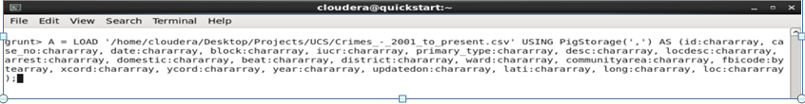

Dumping the relation A to see the loaded records

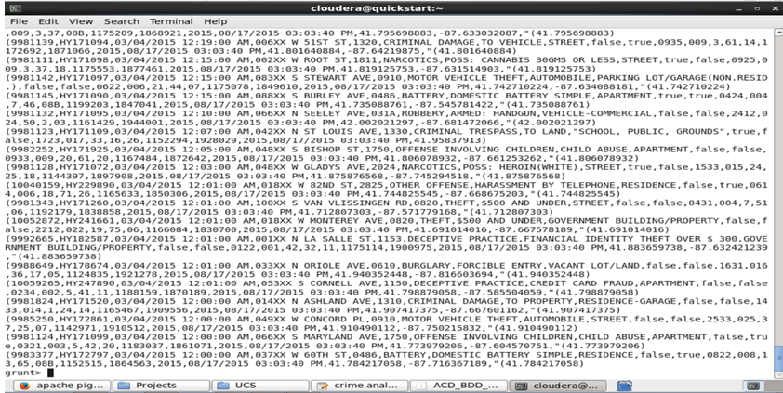

Filtering the record by FBICODE = 32.



Dumping the relation B to see the Filtered record by FBIcode = 32

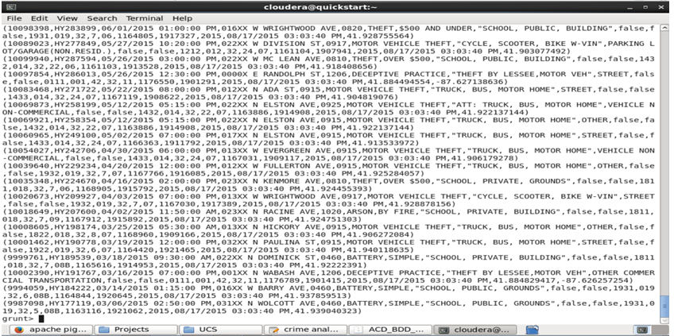

For each relation in B generating the group by Fbicode



Dumping the relation C to see the output

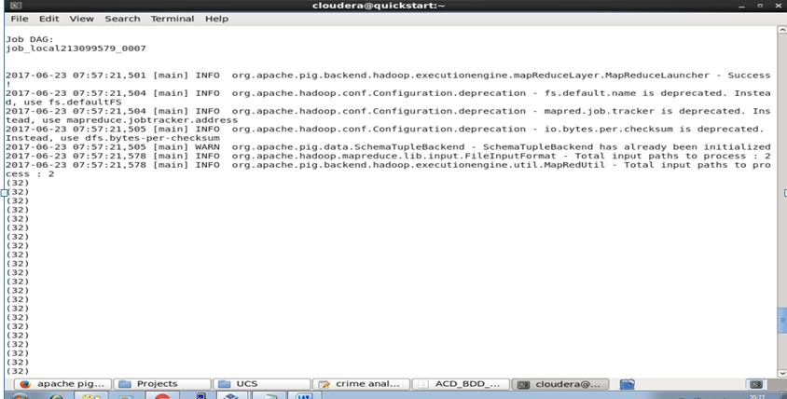

Grouping the relation by ALL and dumping it to see the result



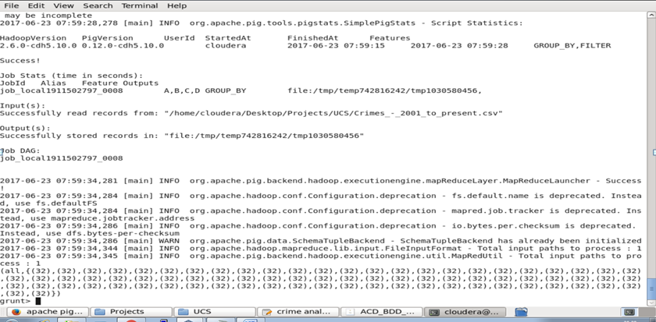



Counting the no of cases investigated under FBI Code = 32 and dumping the result

